
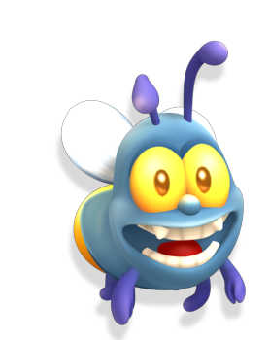
Headup Games Mobile |Press Release
Dueren, 11th April 2013
For further inquiries please contact:
Skander Essadi
Headup Games GmbH & Co. KG Tel: +49 2421 4868703
Nordstr. 104 Fax: +492421 4868709
52353 Düren essadi@headupgames.com


Gorgeous delight for iOS and Android -
Headup Games announces Shiny the Firefly
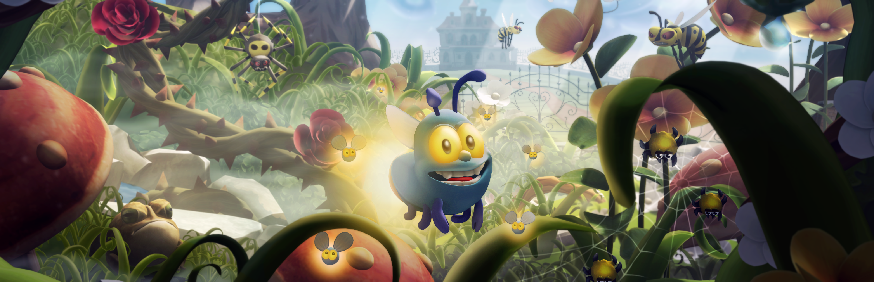

Düren, April, 9th 2013 – Headup Games, together with developer Stage Clear Studios, is very pleased having the honor to announce the multi-platform game Shiny the Firefly.

Even though spring is still on hold, Headup Games treats all iOS-, and Android users with a very special, and colorful highlight soon! Next Thursday (April, 18th 2013) the high quality game Shiny the Firefly will be released, to set new standards in graphics, as well as gameplay

About Shiny the Firefly
This adorable game, set in the middle of a picturesque garden, has you helping Shiny, the cute little firefly, to find his babies. You’ll have to fly, run, hide and defend yourself against a legion of enemies. Stubborn mosquitoes, hungry toads, mischievous plants, sneaky wasps, endlessly long centipedes and lots of other little, dangerous garden dwellers are going to get in your way and make your life difficult.

Your reflexes will be tested, as well as your wit and intellect as you navigate through this beautiful, colorful world helping Shiny in his search. All kinds of different animations let you know how Shiny’s feeling. So you’ll always know if he’s feeling happy, concerned, tired or angry. That will help you solve the trickiest situations in the game. Use your ability to shine skillfully: the babies can only follow Shiny when he is lit up, but that also makes him visible to his enemies…

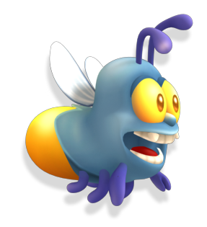
Can you reunite Shiny with his family?
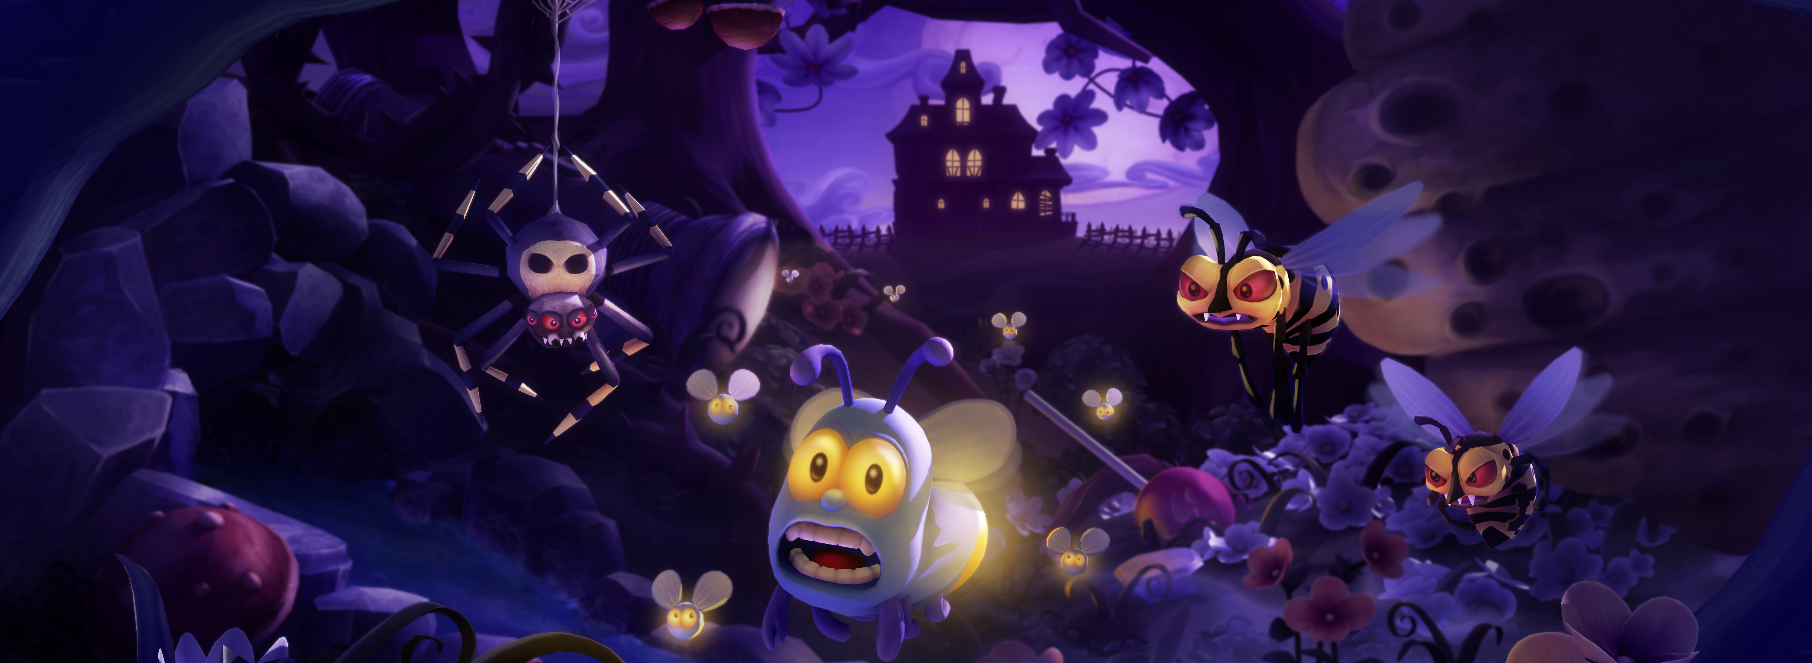


Features

• Unique “Light on, light off” feature
• Great, high-quality graphics
• A charismatic character with numerous animations
• Three different worlds with a total of 33 levels, teeming with enemies, bosses, puzzles and other game elements
• An all-round fully developed and intuitive game experience for everybody
• Game Center integration

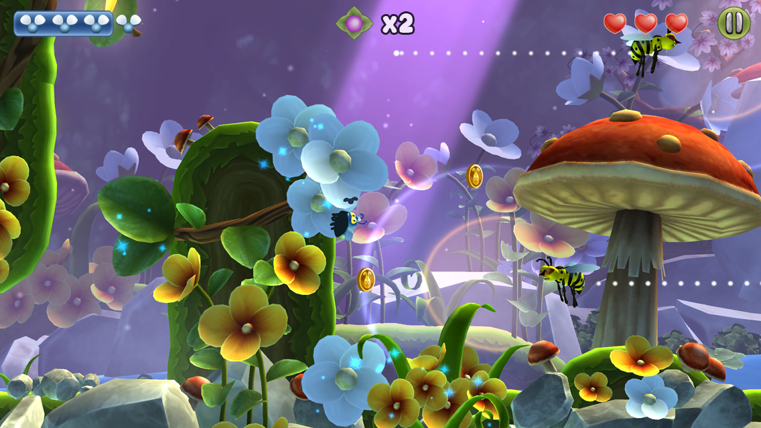
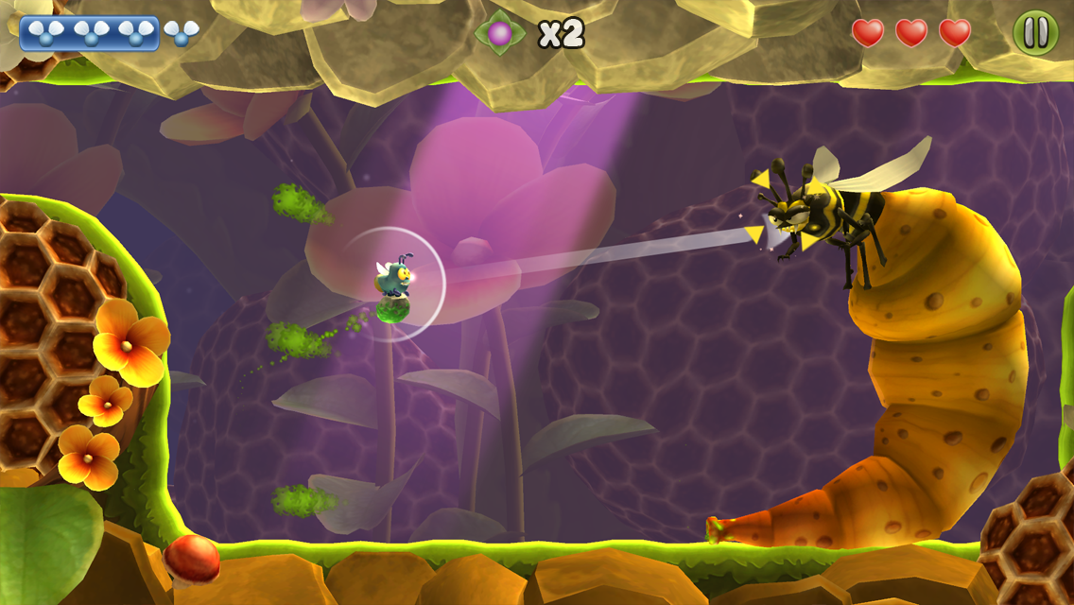

Info
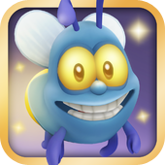
Title: Shiny the Firefly
Platform: Android, iOS
Genre: Action-Adventure
Publisher: Headup Games
Development: Stage Clear Studios
Release: April, 18th 2013 (iTunes, PlayStore)

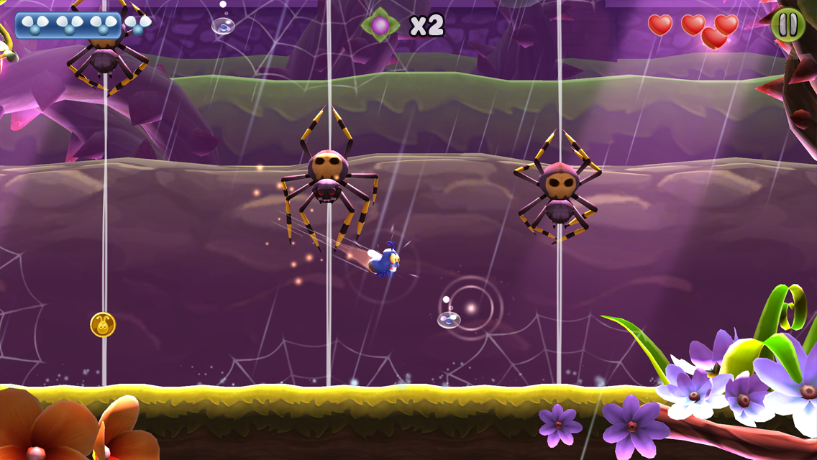

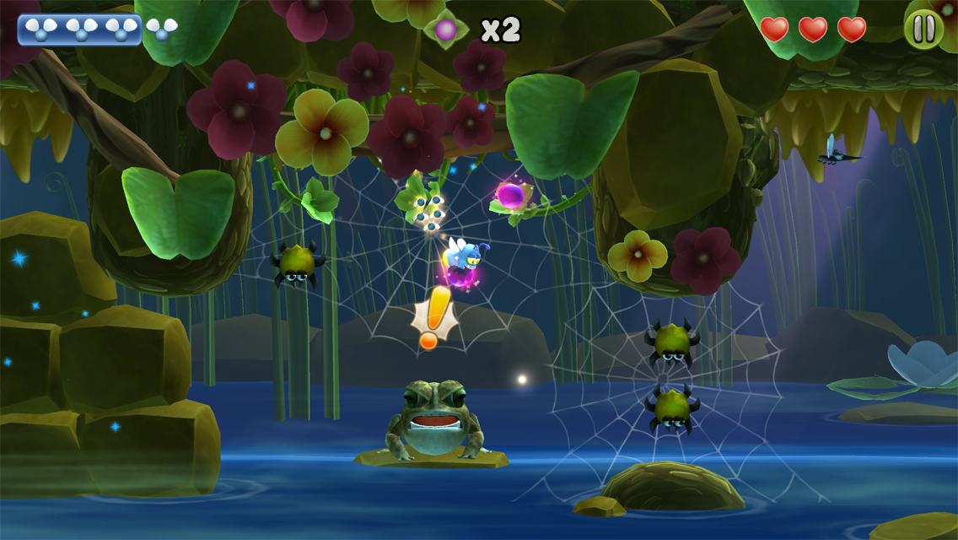

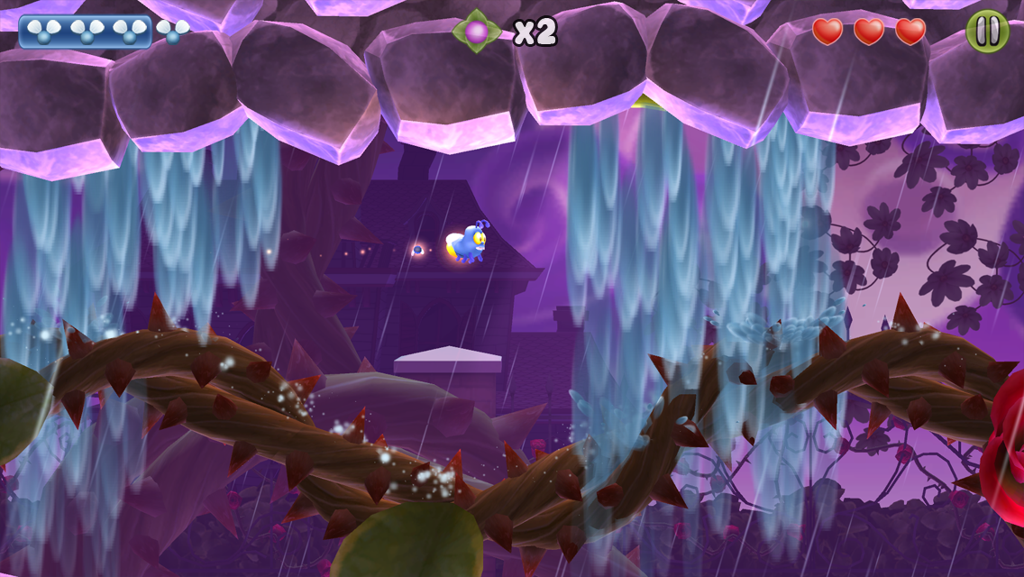


Über Headup Games:
Headup Games GmbH & Co. KG is an independent games publisher located near Cologne in Germany as was awarded as the Best German Publisher in 2012 by the German Developers Association. Together with its partners Headup Games focuses on the contentment of their customers and the best gameplay experience delivered at the fairest price-quality ratio. Since its foundation the company published over 50 SKU’s, including many projects from young, ambitious indie-developers, where much potential and creativity had been seen. The portfolio features high-quality games such as Super Meat Boy, The Binding of Isaac, Terraria, Limbo, Archon: Classic, The Tiny Bang Story, Trapped Dead, Grotesque Tactics, The Binding of Isaac, Q.U.B.E., and Frozen Synapse as well as the million seller and #1 iOS Hit Bridge Constructor.

Furthermore Headup Games offers to internationally growing companies the possibility to enter the German or European market with an experienced partner on location. Fair and transparent relationships to our developing partners are the basis of our company’s mission statement.

More information can be found at www.headupgames.com

About Stage Clear Studios:

